**Overview**

# Background noises are something that we do not usually care about; however, they surprisingly have a significant impact on our daily lives. With busy urban lifestyles, more and more people find hearing natural and comfortable sounds a great way to relax, relieve stress, and increase productivity. It can be the sound of wind blowing from high on top of mountains, the hum of insects and animals deep into the jungle, and also somewhere we are more familiar, like inside of the coffee shop where we hear people chatting along with the melodies of the songs. That idea, combined with our love of coding and technologies, has inspired us to build a small website where people can enjoy some unique sounds of different places. Moreover, users can also adjust relative sound levels to achieve perfectly balanced background noise. We call it “Mix in Sounds” or “MinS”.

**Motivation**

​In recent years, the occurrence of Covid-19 has brought to our lives many changes and most of them are tremendously bad. To lessen Coronavirus impact, people are encouraged to apply social distancing methods, which include limiting travel, staying home, and avoiding crowded areas. As the result, many people have to cancel their vacations and stay at home all day long. These experiences are, sometimes, quite boring and exhausted. We believe that listening to music or some sort of natural melodies is one of the best ways for people to relax and to have a feeling of traveling elsewhere.

According to soundofsleep.com [[1]](https://www.soundofsleep.com/white-pink-brown-noise-whats-difference/), background sounds that usually contain white noise have been shown to have promising results in improving behaviors and productivity. To be specific, it helps us enhance memories, deepens our meditation, sleep quality as well as improves concentration. MinS is developed to bring people a better quality of life with its pristine soundtracks and beautiful photographs. In addition, this website also provides Pomodoro – a study tracking tool that people can use while studying and Spotify integrations if they want to enjoy some nice playlist of songs. MinS differs from other background noise generator by it high quality audio and the huge number sounds provided. Anyone can access the website right on their phones, tablets, or laptops, and it will be available on famous browsers like Google Chrome, Safari, Microsoft Edge, and Firefox.

**Description**

**FUNCTION**

In general, MinS is a simple and easy-to-use website. When we first open up, the whole screen will be covered in black, and the logo will slowly appear. After that, it displays, under the logo, “Welcome to Mix in Sounds”, followed by a short description of the website. Users will then be asked to choose between four locations - Chilling by the Sea, Exploring the Forest, Relaxing in a Coffee Shop, and Working at the office – which is shown in turn. The website will play a demo sound of that place along with beautiful scenery in the background interface for each location. After choosing the desired location, the website will relocate them to a new page, and more soundtracks will be provided. To be more specific, inside the forest, we can hear the light wind, vibrating trees, insects buzz, campfire, as well as the sounds of animals like birds, snakes, and monkeys. When choosing the seaside option, we can hear waves crashing on the shore, sand crunching underfoot, the sound of seagulls and other coastal birds. If users choose to go to a bustling area like a coffee shop, there will be the sound of people chatting, the barista who prepares the beverage for us, the coffee cup, and the drinking sound. Last but not least is at the office where users can hear the sound of discussion, people moving around, writing, and studying. There are also different kinds of weather used in all locations which are rainy, windy, sunny, and snowy. When users first come to a location, there will be a default set of sounds chosen by the host to bring a light touch of that place. They can then modify and choose the desired soundtracks to enjoy. It is important that all of the sounds must be of high quality to provide the best user experience.

**LAYOUT & DESIGN**

In terms of the layout, the header, where the website logo and different locations are located, will lie on top of the window, and users can navigate to other places by clicking on them. The set of sounds will be on the right side of the screen. There will be a control bar for each sound for users to adjust. They can choose the sounds they desire by clicking on the play button and dragging the circle dot to the right for higher volume and the other for lowering. The play button will then be changed into the pause symbol in case users want to stop the sound.

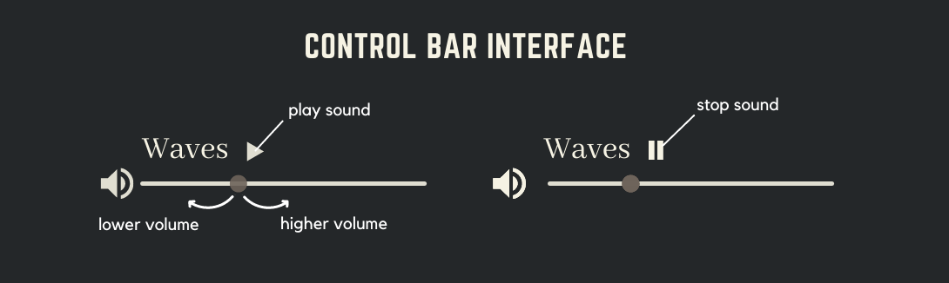

i. Control Bar Interface

Underneath the sounds control panel, there are four circles with an icon inside, representing the weather mentioned before. Users can hold their mouse on that button, drag it up or down to adjust the volume.

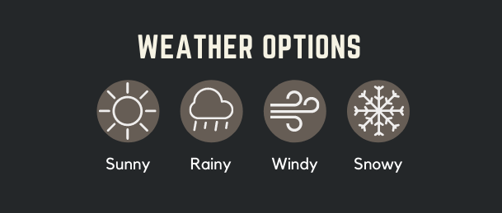

ii. Weather Options

For music lovers, the Spotify player is located on the left side of the window and has some default music chosen by the host. If the users have a premium Spotify account, they can also log in and enjoy the entire length of the songs instead of the 30s each. The sound adjusting bar and playback & skip button are also provided for the users for better adjustment.

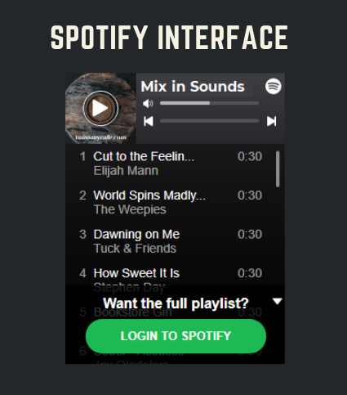

iii. Spotify Interface

Pomodoro is one of the trending education tools to help us keep track of our studies time and work effectively. It will be included on the website and displayed on top of the Spotify player. The default option is 25 minutes of working time, followed by 5 minutes of break. Users could also adjust the desired time by clicking on the “EDIT” button. After that, the interface of the Pomodoro will change, and there will be two arrows up-down for us to choose the desired working time.

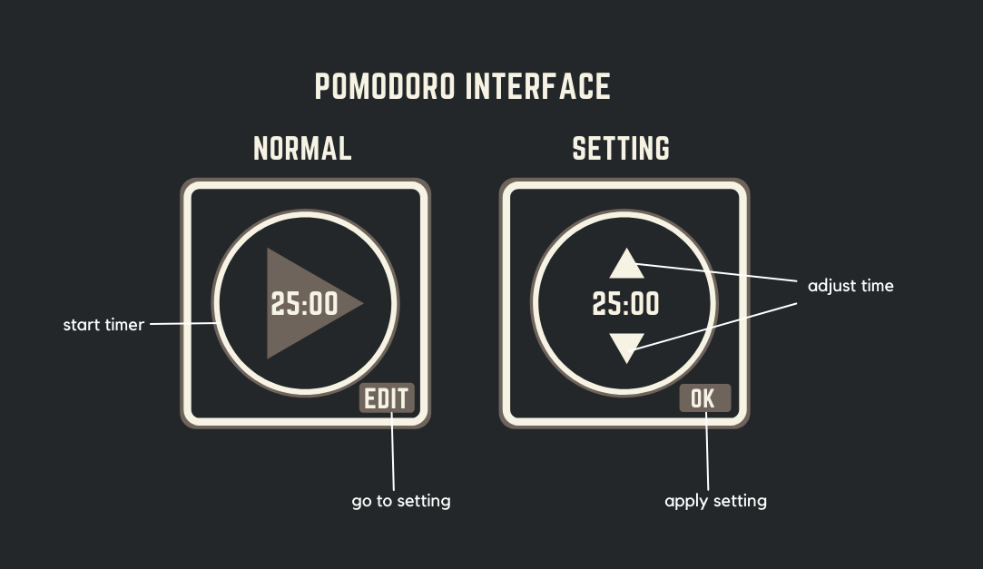

iv. Pomodoro Interface

If the users are satisfied with the website, they can also support us by clicking on the “Support us” button on the bottom left of the interface. They will then be taken to a page where users can find more information about the creators and send a small donation. On the right side of the donation box is some extra information about the website, including the creators, the releasing date, and our slogan. Here is a demo design of the interface for better visualization:

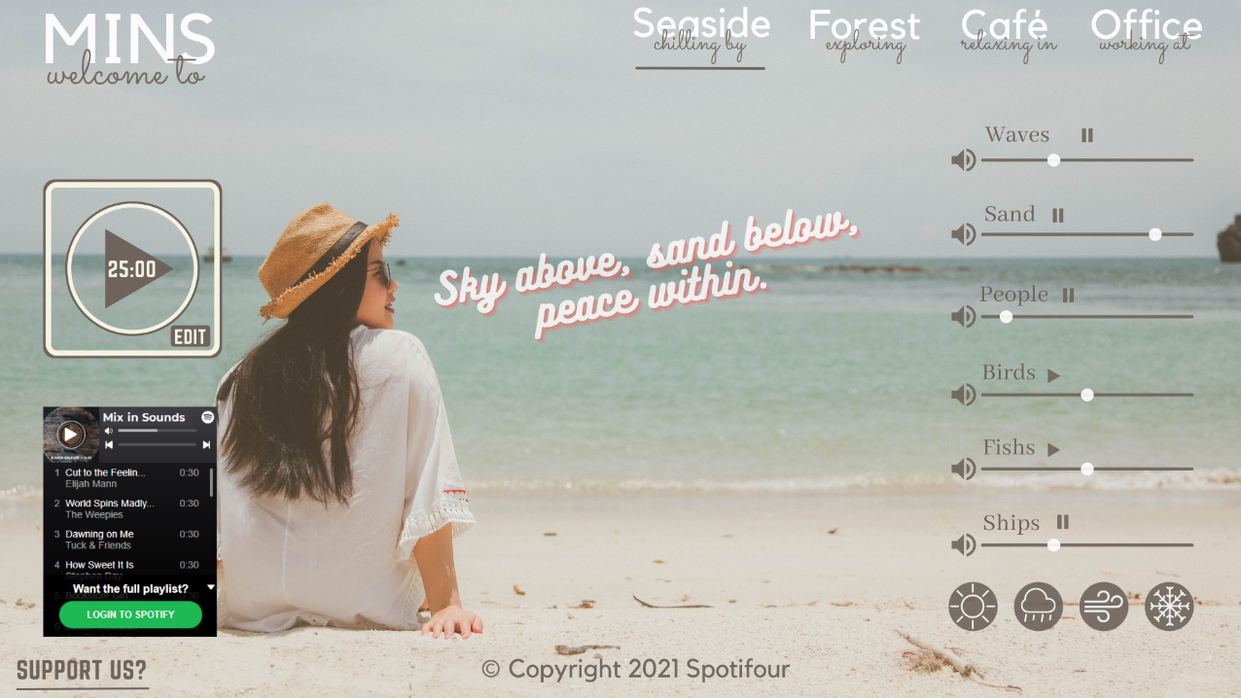

v. Seaside interface

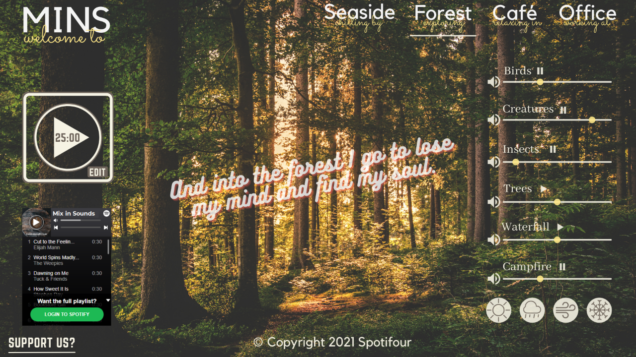

vi. Forest Interface

The color and size of every button will change slightly if the users hover their cursor on them. In addition, if they hover on each button, there will be a comment pop-up to provide some additional information about that button. The color and font shown on the website will depend on the background pictures of different locations. Moreover, we would like to use not too bright colors for the website along with stylish and exquisite fonts.

**Tools and technologies**

The main technology for building this project is [ReactJS](https://reactjs.org/) [2]. It is utilized for building front-end components, including the sounds control panel, header, Pomodoro section, etc. HTML and CSS will also be used for structuring and styling the project. In addition, Spotify API will be integrated into the website for playing songs and users' logins. For the soundtracks, some sounds would be easy for us to record while others need to rent from other sources like [My Noise](https://mynoise.net/) [3]– one of the best background noise generators on the internet. To have high resolution and nice-exposure pictures, we can use images from [Unsplash](https://unsplash.com/) [4] – a photo discovery platform for free-to-use, high-definition photos. In addition, [Firebase](https://firebase.google.com/) [5] will be used to store the database, different sound packages, and high-quality pictures. Finally, we will use GitHub and Git for handling version controls and remote repositories.

**Skills required**

In order to build this website, it is crucial to be proficient at languages and frameworks for frontend development like HTML, CSS, JavaScript, React.JS library. In addition, getting familiar with Firebase and RestAPI could help us work with the Spotify API and backend server. We also need to know about design principles: the font of the letter, the size, colors, and layout of different components to build a nice-looking interface for the project. Furthermore, being familiar with Git and npm command-line interface (including add, commit, push, and pull commands) and managing remote repositories on GitHub is also required. Last but not least, interpersonal skills and teamwork skills to collaborate with other team members are also essential to have.

**Outcome**

We aim to start MinS with a website platform and then transition to a mobile application that can run on both IOS and Android devices. RMIT students will be the first to utilize MinS before it is made available to other Internet users. If this project is successfully deployed, people will have a nice place to relax and enjoy high-quality melodies even if they are in bustling areas of the city. In addition, people can also use MinS while studying to improve concentration and efficiency or while sleeping to have a good relaxation. In the future, we will frequently upgrade MinS with more locations and soundtracks, as well as fix and modify the website according to users' feedback at the same time.